Gym Membership System

1. Creating the tables.

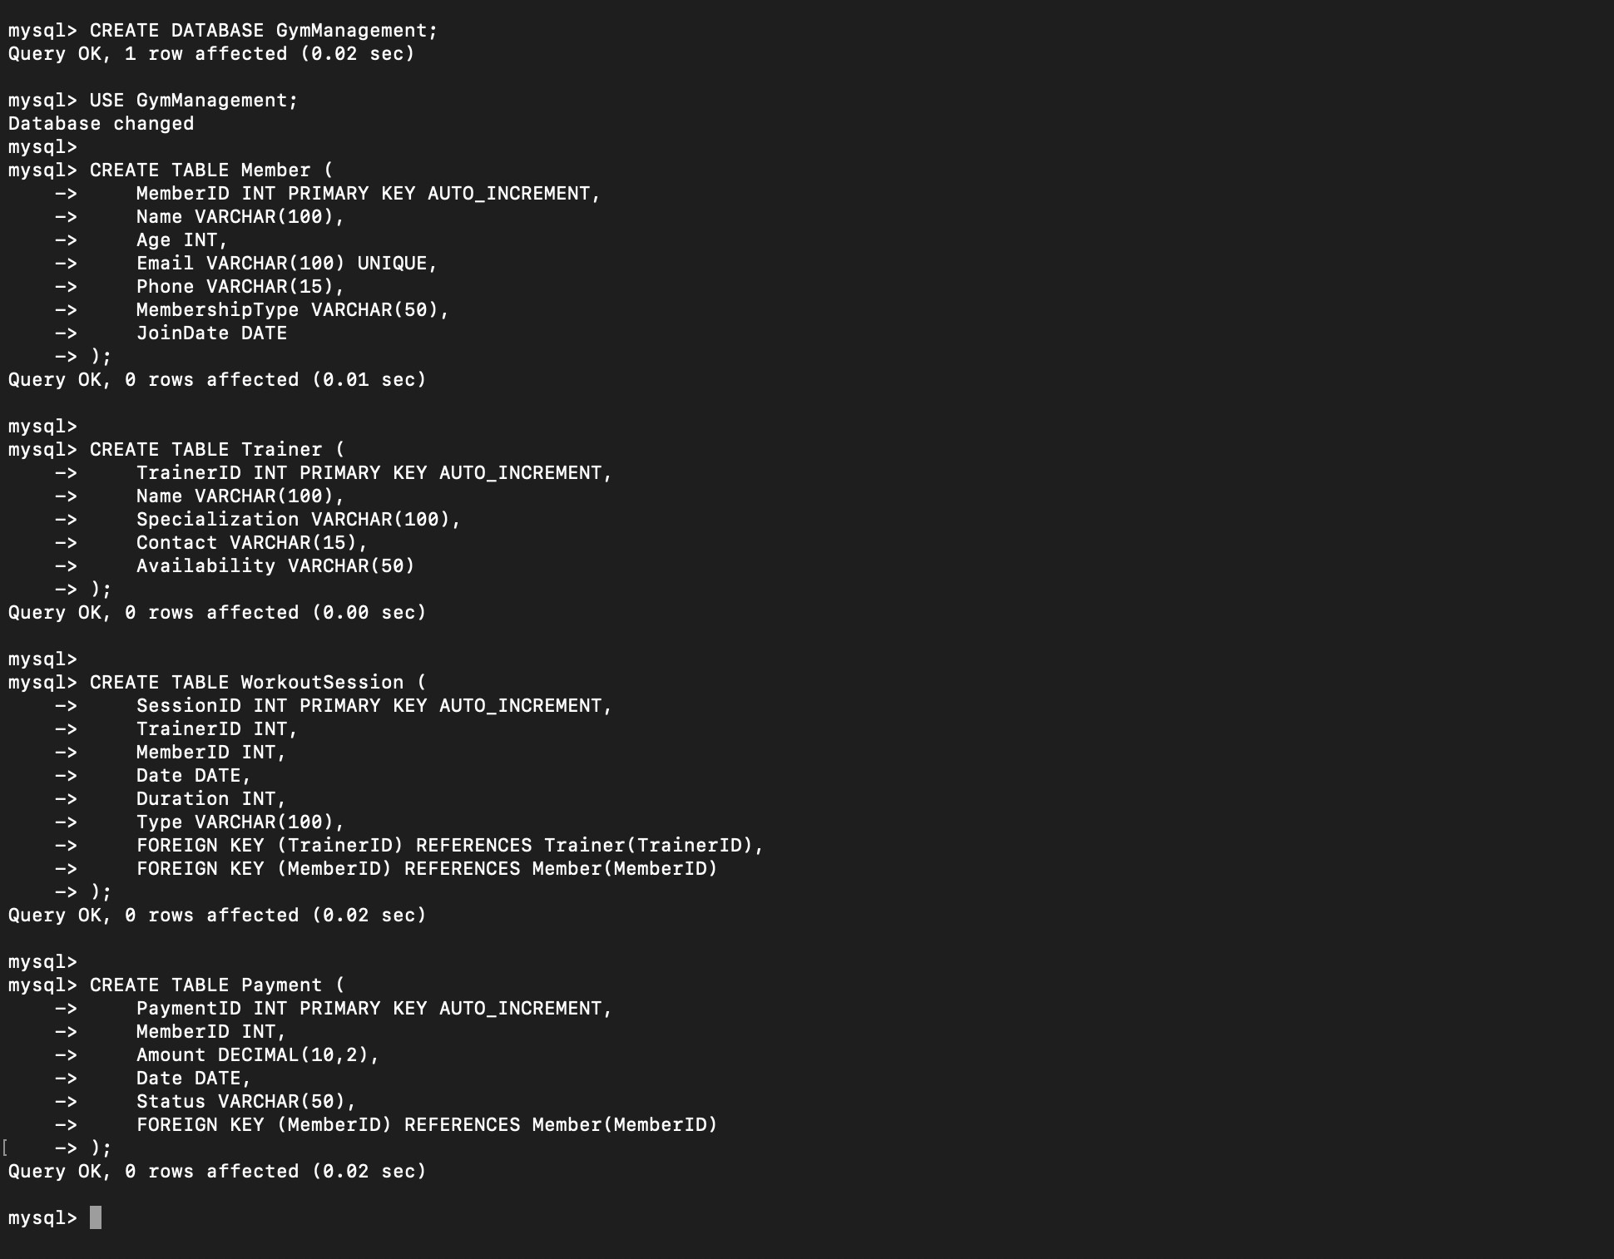

1. Inserting sample data.

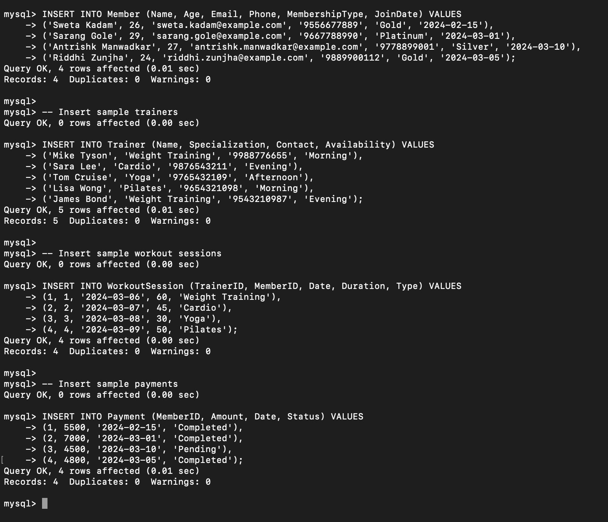

1. Retrieve all members with an active membership.

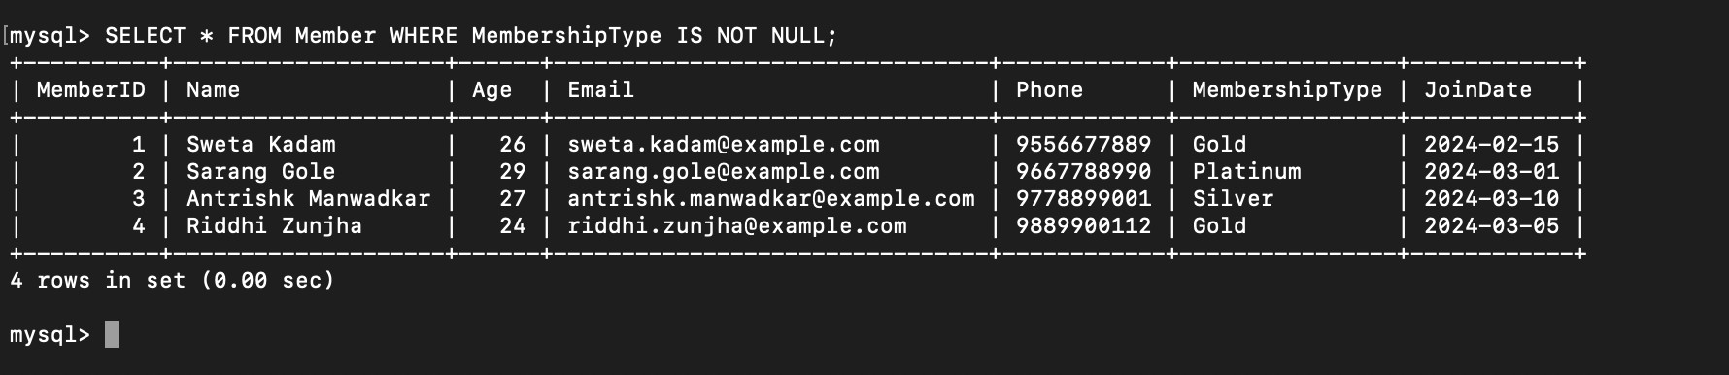

1. Find the trainers specializing in “Weight Training.”

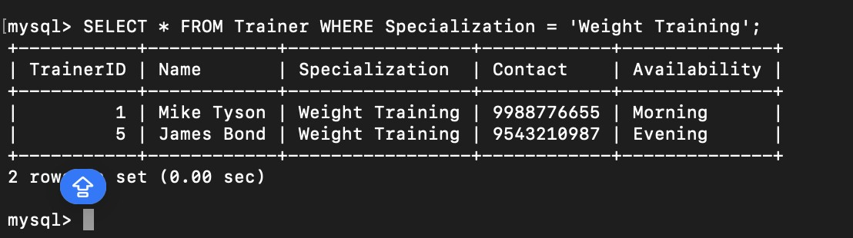

1. Display total revenue from membership payments.

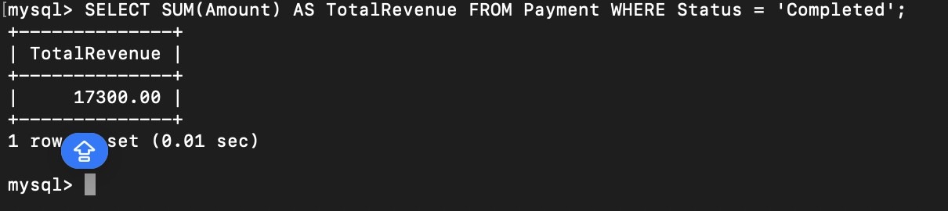

1. Retrieve members who haven’t attended a session in the last 30 days.

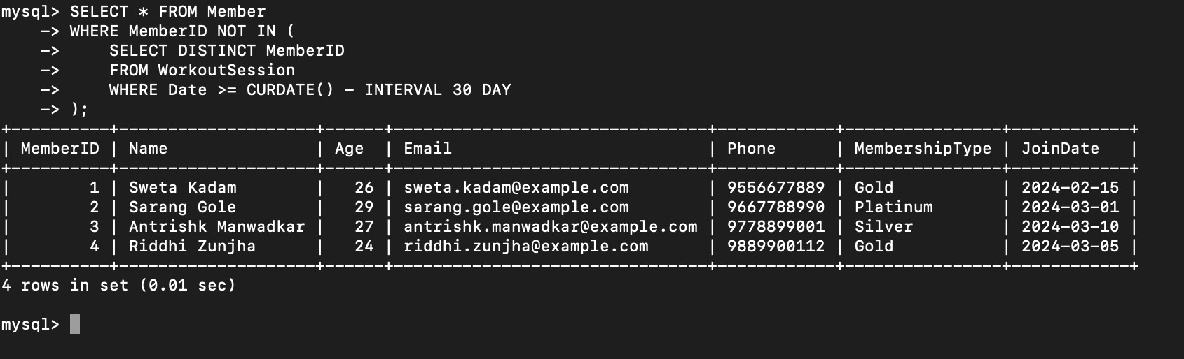

1. Find the most popular workout session type.

